**Target Pembuatan Robot**

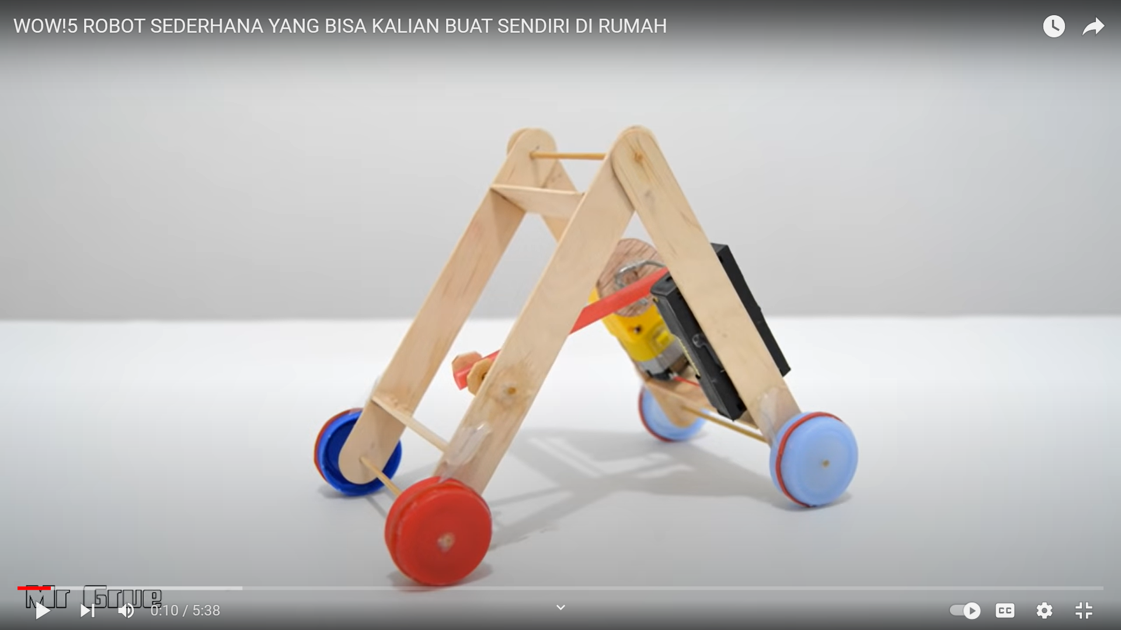

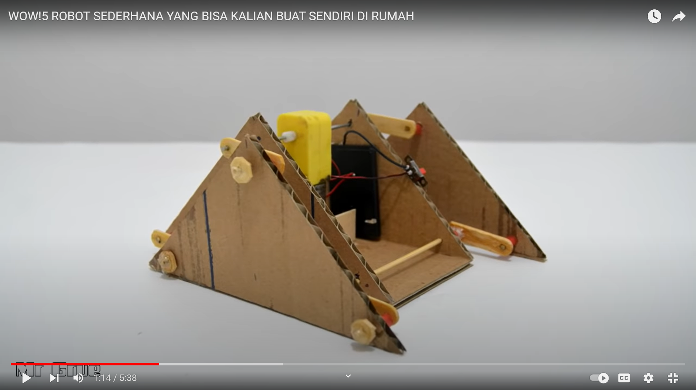

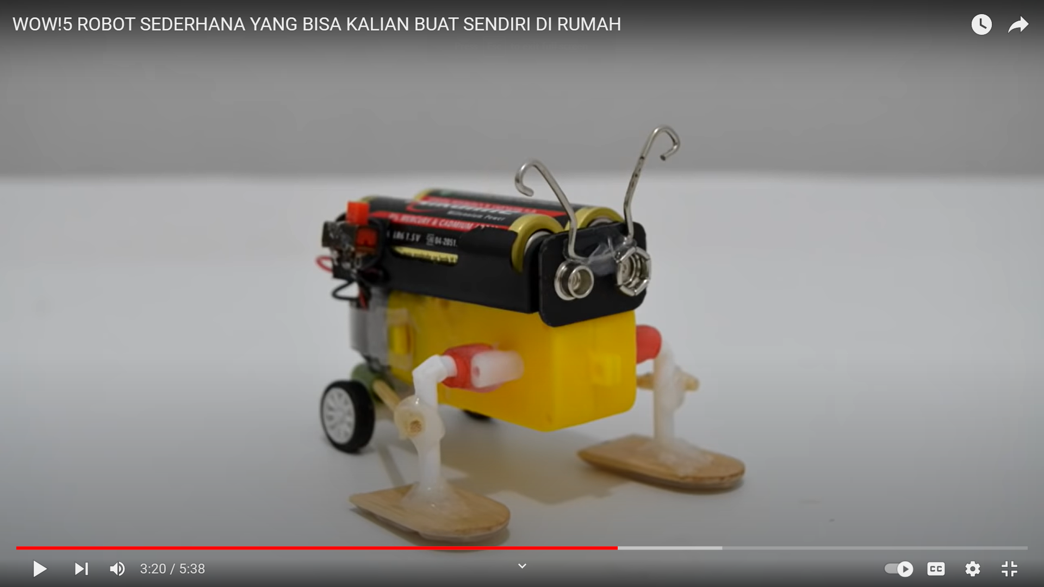

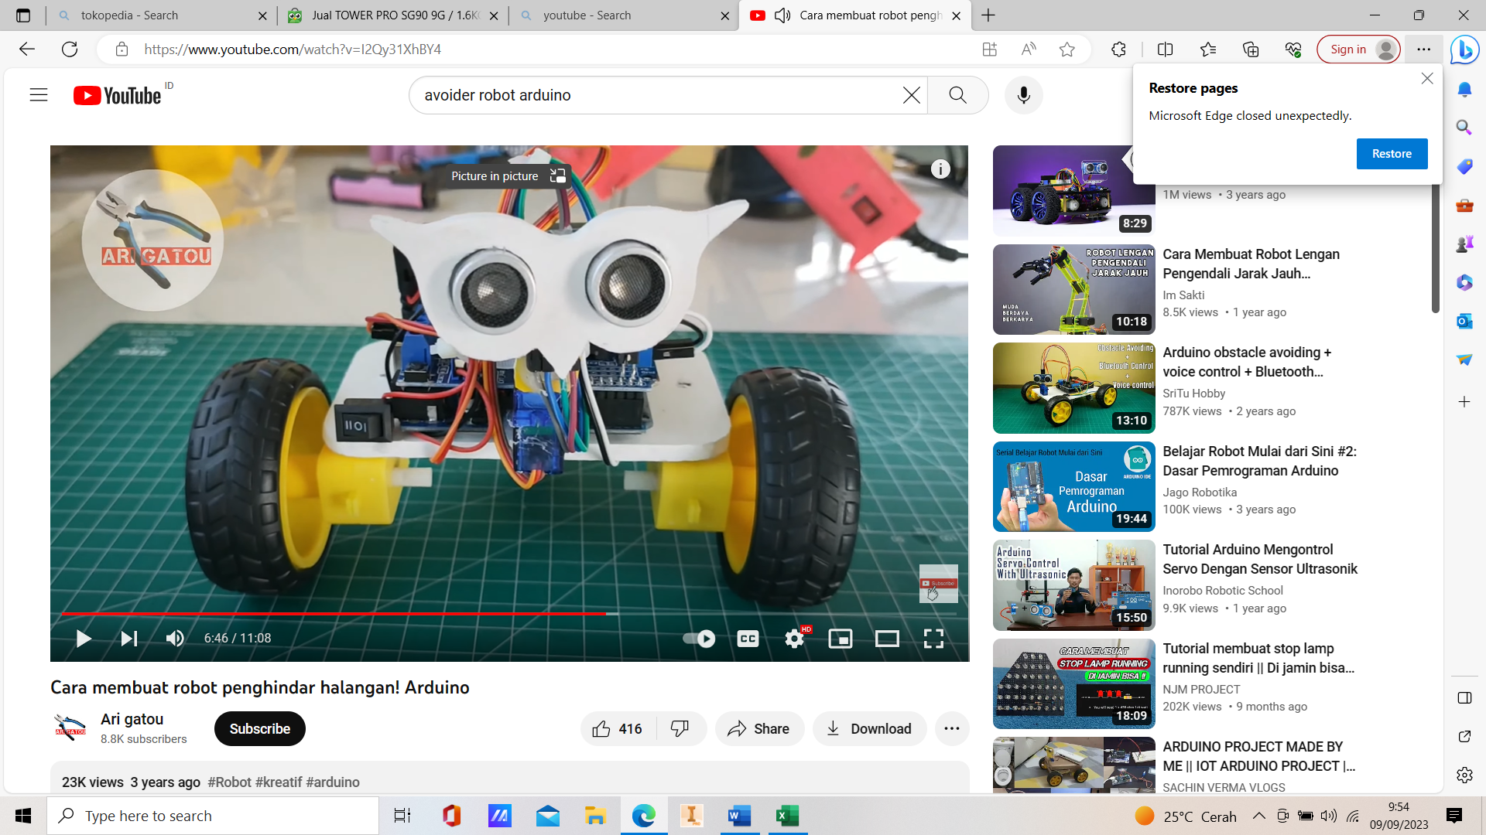

**List Komponen Robot Kelas 1-2**

|  |  |  |  |  |
| --- | --- | --- | --- | --- |
| No | Nama Komponen | Harga Satuan | Jumlah Unit | Jumlah Harga |
| 1. | MOTOR DC TT GEARBOX KUNING 1:48 3-7.2V | Rp. 9.000,00 | 4 | Rp. 36.000,00 |
| 2. | Roda ban kuning D65mm untuk motor gearbox kuning TT | Rp. 5.000,00 | 2 | Rp. 10.000,00 |
| 3. | Box Baterai 2x Size 18650 with Jack DC Holder Battery 18650 2 x 18650 | Rp. 7.000,00 | 1 | Rp. 7.000,00 |
| 4. | MINI SOLDERLESS BREADBOARD 400 TIE POINTS 400 TITIK COCOK DENGAN MB102 | Rp. 12.500,00 | 1 | Rp. 12.500,00 |
| 5. | Kabel Jumper 20 Cm Male-Male/Male-Female/Female2 Ecer 1pcs | Rp.500,00 | 20 | Rp. 10.000,00 |
| 6. | L298N MOTOR DRIVER MODULE | Rp. 20.000,00 | 1 | Rp. 20.000,00 |
| 7. | HC-SR04 Sensor Ultrasonic | Rp. 14.000,00 | 1 | Rp. 14.000,00 |
| 8. | TOWER PRO SG90 9G / 1.6KG / .12SEC MICRO SERVO | Rp. 19.000,00 | 1 | Rp. 19.000,00 |
| 9. | Baterai 18650 VTC6 3000mAh 20a flat top 18650 sony VTC 6 free case battery | Rp. 17.000,00 | 2 | Rp. 34.000,00 |
| 10. | Arduino Nano ATMEGA328P CH340 IC | Rp. 58.000,00 | 1 | Rp. 58.000,00 |
| Total Harga | | | | Rp. 220.500,00 |

|  |  |  |  |
| --- | --- | --- | --- |
| Nama Komponen | Harga perunit | Jumlah unit | Total |
| SAKLAR ON-OFF AC KCD3-101N ROCKER SWITCH | Rp. 3.000,00 | 3 |  |
| MOTOR DC TT GEARBOX KUNING 1:48 3-7.2V | Rp. 9.000,00 | 1 |  |
| FEMALE DC JACK POWER ADAPTER | Rp. 2.000,00 | 1 |  |
|  |  |  |  |